🌼 What is Java? (Corrected and Simple Notes)

✔️ Java is both a programming language and a platform.
It is a high-level, object-oriented, and secure programming language.

🌼 History of Java
- Java was developed by Sun Microsystems in 1995.
- The main creator of Java is James Gosling (along with his team).
- Before the name Java, the language was called Oak.
- The name was changed from Oak to Java because
Oak was already a registered company name.

🌼 Why Java is called a Platform?

👉 First understand: What is a Platform?
A platform is like a stage where your program runs.
Examples:
- Windows is a platform
- Android is a platform
- iOS is a platform
A platform gives everything needed for a program to run.

🌼 Now, why Java is called a platform?
Java is called a platform because it gives a complete environment to run Java programs.
Java provides 2 major things:

1️⃣ JRE (Java Runtime Environment)
Think of JRE as the engine that runs your Java program.
JRE contains:
- JVM (Java Virtual Machine) → executes the bytecode
- Necessary libraries
- Runtime support files
👉 Without JRE, Java programs cannot run.
Example:
When you double-click a .class or .jar file, JRE is the one that actually runs it.

2️⃣ API (Java Libraries)
API is like a huge toolbox given by Java.
It includes:
- Collections (List, Set, Map)
- File handling
- Networking
- Database connectivity
- GUI libraries
- Utility libraries
You don’t need to write everything from scratch. Java already gives you ready-made building blocks.

🌼 Together JRE + API = Java Platform
✔️ JRE → makes your program run
✔️ API → gives you features to build programs
So Java gives:
- a place to run programs
- tools to build programs
This is why Java is more than just a language.
It behaves like its own software platform.

class Hello{
public static void main(String args[]){
System.out.println("Hello world");
}
}

Explanation of Each Java Keyword in the main() Method

1. class
- class keyword is used to declare a class in Java.
- A Java program must have at least one class.

2. public
- public is an access modifier.
- It means the method/class is visible to everyone.
- The JVM must be able to access the main method, so it must be public.

3. static
- static is a Java keyword.
- A static method belongs to the class, not to an object.
- So you do not need to create an object to call it.
- The JVM directly calls the main() method without creating any object → saves memory.

4. void
- void is the return type.
- It means the method does not return any value.

5. main
- main is the starting point of every Java program.
- JVM looks for the main() method to start execution.

6. String[] args (or String args[])
- This is used for command-line arguments.
- JVM passes additional values (if any) through this array.

7. What exactly is System.out.println()?
Think of it like sending a message to the console.
Break it into 3 parts:

🔹 1. System → A Big Built-In Helper Class
System is a class already created by Java.
It contains many useful things like:
- ways to print output,
- ways to read input,
- system properties,
- time info, etc.
You don’t create an object of System.
JVM automatically loads it when your program starts.

🔹 2. out → A Ready-Made Object Inside System
Inside the System class, there is a static variable called out.
What is out?
- It is an object of a class called PrintStream.
- Because it is static, we don’t need to create System object.
- It can be accessed classname.variablename so System.out

🔹 3. println() → A Method That Prints the Message
println() is a method inside the PrintStream class.
What does it do?
- It prints whatever you give inside brackets.
- Then it moves the cursor to next line.
Like:
System.out.println("Hello");

🌼 Put all together as a chain

✔️ System
↓ gives

✔️ out (a PrintStream object)
↓ calls

✔️ println() method
➡️ finally prints the message on screen.
So the chain is:
System -> out -> println()

How System.out.println() Works
- JVM does NOT create an object of the System class.
The System class is only loaded when the program starts.
- The System class contains a static variable named out.
- out is not a System object.
It is an object of the PrintStream class.
- Because out is static, we can access it using the class name:
- System.out
- The println() method belongs to the PrintStream class.
- So when we write:
- System.out.println("Hello");
it means:
  - Go to the System class
  - Access the static variable out (a PrintStream object)
  - Call the println() method on that PrintStream object
- Therefore, there is no need to create an object of the System class to print text.

To compile :
javac Hello.java
To Excecute :
java Hello

Give the same class name and file name.
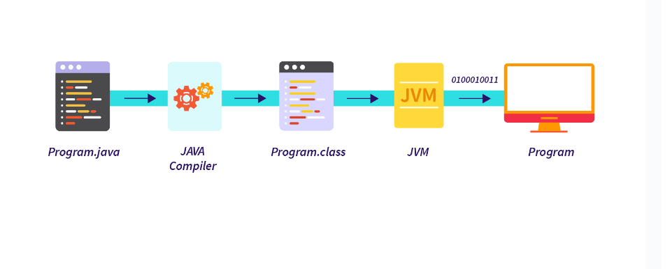

🌼 What is the main() method?
main() is the starting point of every Java program.
When you run a Java program, the JVM looks for the main() method first.
👉 If JVM finds main(), it starts executing the code inside it.
👉 If you don’t write main(), the program will not run (you get an error).
So:
main() = entry gate of the program

🌼 Why JVM needs main()?
Think of JVM like a person entering a house.
To enter, the person must use a main door.
In Java:
- main() = main door
- JVM enters the program through this door only
If the main door is missing → JVM cannot enter → program won’t run.

🌼 About .class files (Very simple explanation)
When you write a Java program:
class A {
}

class B {
}
and then compile it…
Java compiler (javac) creates one .class file for each class.
So:
- class A → A.class
- class B → B.class
✔️ If you have 2 classes, you get 2 .class files
✔️ If you have 5 classes, you get 5 .class files
Because each class is compiled separately.
Eg: Main

🌼 Important Point
Only the class that contains the main() method is the one that JVM will execute first.
Other class files may be used, but JVM will not start from them.

🌼 Example to make it super easy
class Test {
public static void main(String[] args) {
System.out.println("Hello");
}
}

class Demo {
}
After compilation, you will get:
- Test.class
- Demo.class
But when you run:
java Test
Only Test.class is executed because it has main().
Demo.class just exists, but JVM will not enter it directly.

Eg: Main_Without_String_Args

🌼 Important Rule
JVM will run your program only if it finds this exact method:
public static void main(String[] args)
- public
- static
- void
- main
- and parameter String[] args
If any part is changed → JVM will not recognize it as the main method.

🌼 Now your point:

“The program will compile, but we cannot run it.”
Yes dear, this is 100% correct.
Why?
👉 Compilation only checks whether your syntax is correct.
👉 Running the program needs a proper main() method.
So if you write:
public static void main() {
System.out.println("Hello");
}
or
public static void main(int[] args) {
System.out.println("Hello");
}
or
public static void main(String args) {
System.out.println("Hello");
}
✔️ These will compile
❌ But they won't run
Because JVM says:
“I only understand main(String[] args)”

🌼 Why does JVM want String[] args exactly?
Because JVM passes command-line arguments to your program.
Example: when running like this:
java Main Hello World
These values are stored in the String[] args array.
So JVM needs:
- String type
- Array
- Name doesn’t matter → args, x, pavan anything is ok
But type MUST be String[].

🌼 Example: Wrong main()
public class Test {
public static void main() { // ❌ Wrong
System.out.println("Hi");
}
}
✔️ Compiles
❌ Error when running
Error:
Main method not found

🌼 Example: Correct main()
public class Test {
public static void main(String[] args) { // ✔️ Correct
System.out.println("Hi");
}
}
✔️ Compiles
✔️ Runs

🌼 Simple Analogy
JVM is like a person who only enters a house through a specific door.
That door is:
public static void main(String[] args)
If the door shape or size changes → JVM cannot enter → program doesn’t run.

Eg: Program_Without_Main_Method_With_Static_Block

🌼 🔥 Can we run a Java program WITHOUT a main() method?
👉 Old Java versions (up to Java 1.6)
Yes, you could run a program without main() if you used a static block.
👉 New Java versions (Java 7 and above)
No, you cannot run a program without main(), even if you have a static block.

🌼 What is a static block?
(Just for basic idea)
A static block is a block that runs before main(), only once, when the class is loaded.
Example:
static {
System.out.println("I am static block");
}
But we will learn this in detail later.

🌼 ✔️ Case 1: Java 1.6 and older
class Demo {
static {
System.out.println("Hello from static block");
}
}
In old Java, this ran successfully because JVM allowed class loading to run static block even without main().

🌼 ✔️ Case 2: Java 7 and newer (JDK 17 also)

👉 Program WITH static block BUT WITHOUT main()
class Demo {
static {
System.out.println("Hello from static block");
}
}
✔️ This will compile
✔️ .class file will be created
❌ But you cannot run it
JVM gives error:
Error: Main method not found in class Demo
Because JVM does not allow running a program without main().
So in JDK 17:
👉 Program compiles
👉 But cannot run

🌼 ✔️ Case 3: Program WITHOUT static block AND WITHOUT main()

Empty class (NO main(), NO static block)
class Demo {
}
👉 This WILL compile.
👉 A .class file WILL be generated.
👉 But you CANNOT run the program.

Why?
Because the compiler only checks:
- Is the syntax correct?
- Is the class written properly?
An empty class is perfectly legal in Java.
So compiler says:
“Okay, I will create Demo.class”
But when you try to run it:
java Demo
JVM says:
Error: Main method not found in class Demo
Because JVM needs a main() to run.

Program Type | Compiles? | .class Created? | Runs?
Empty class (no main, no static block) | ✔️ Yes | ✔️ Yes | ❌ No
Static block + no main (Java 7+) | ✔️ Yes | ✔️ Yes | ❌ No
main() method present | ✔️ Yes | ✔️ Yes | ✔️ Yes

// we will learn method overloading further. For now just understand the below thing.

🌼 Different Ways of Method Overloading in Java
Method overloading means same method name, but different parameters.
You can overload a method in these ways:

✔ 1. Changing the Number of Parameters
void test(int a) { }
void test(int a, int b) { }

✔ 2. Changing the Data Types of Parameters
void test(int a) { }
void test(double a) { }

✔ 3. Changing the Order of Parameters
void test(int a, String b) { }
void test(String b, int a) { }

Main method can be overloaded, but the JVM calls only the one with the regular format:
public static void main(String[] args)
The other overloaded main methods will not be called automatically.
You need to call them manually from inside the main method.
Eg: Main_Method_Overloading

